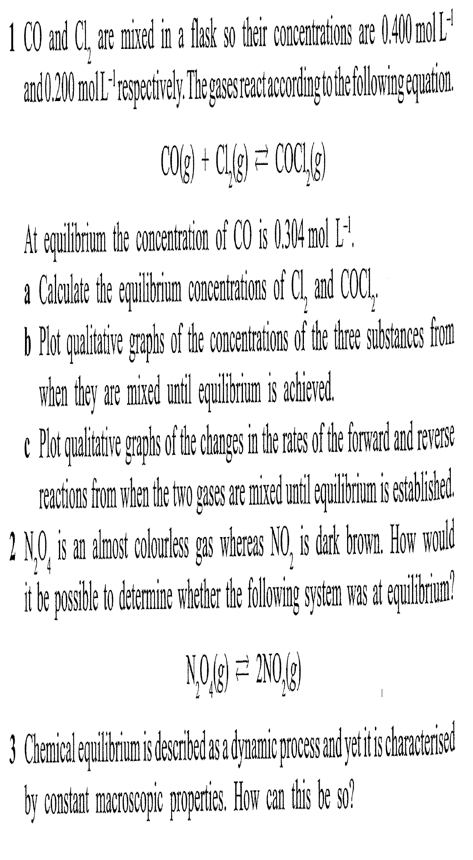
CHEM 3AB EQUILIBRIUM Assignment (Foundations of Chemistry)

